Experiment 10

CREATE TABLE STUDENT_7 ( sid INT PRIMARY KEY, sname VARCHAR(50), dept VARCHAR(50), marks INT);
SET SERVEROUTPUT ON;
SHOW SERVEROUT;

CREATE OR REPLACE TRIGGER trg_check1_marks
BEFORE INSERT ON STUDENT_7
FOR EACH ROW
BEGIN
IF :NEW.marks < 0 THEN
RAISE_APPLICATION_ERROR(-20001, 'Marks cannot be negative');
END IF;
END;

INSERT INTO STUDENT_7 VALUES (1, 'Anu', 'CSE', -85);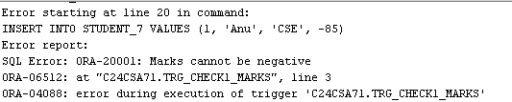
INSERT INTO STUDENT_7 VALUES (1, 'Anu', 'CSE', 85);
CREATE TABLE customer_details (cust_id INT, cust_name VARCHAR(30),address VARCHAR(30));

CREATE TABLE emp_details ( empid INT,empname VARCHAR(30), salary INT);

CREATE TABLE cust_count ( count_row INT);

1) CREATE OR REPLACE TRIGGER tri
AFTER INSERT ON customer_details
FOR EACH ROW
BEGIN
DBMS_OUTPUT.PUT_LINE('A row is inserted');
END;
/
INSERT INTO customer_details (cust_id, cust_name, address)
VALUES (1, 'Anu', 'Kochi');

SQL> INSERT INTO customer_details (cust_id, cust_name, address)
VALUES (1, 'Anu', 'Kochi')
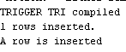

2) CREATE OR REPLACE TRIGGER trig
AFTER INSERT ON emp_details
FOR EACH ROW
WHEN (NEW.salary > 20000)
BEGIN
DBMS_OUTPUT.PUT_LINE('Salary is greater than 20000');
END;
/

INSERT INTO emp_details(empid, empname, salary)
VALUES (2, 'Alen', 30000);
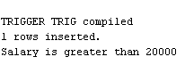
3) CREATE OR REPLACE TRIGGER trigg
BEFORE INSERT OR DELETE ON customer_details
FOR EACH ROW
BEGIN
IF DELETING THEN
UPDATE cust_count
SET count_row = count_row - 1;
ELSE
UPDATE cust_count
SET count_row = count_row + 1;
END IF;
END;
/

INSERT INTO customer_details VALUES (1, 'Anu', 'Kochi');
DELETE FROM customer_details WHERE cust_id = 1;

SELECT * FROM cust_count;

4) CREATE TABLE deleted (
empid INT,
empname VARCHAR(30),
salary INT
);

CREATE TABLE updated (
empid INT,
empname VARCHAR(30),
salary INT
);
CREATE OR REPLACE TRIGGER trigge
BEFORE DELETE OR UPDATE ON emp_details
FOR EACH ROW
BEGIN
IF DELETING THEN
INSERT INTO deleted
VALUES (:OLD.empid, :OLD.empname, :OLD.salary);
ELSE
INSERT INTO updated
VALUES (:NEW.empid, :NEW.empname, :NEW.salary);
END IF;
END;
/
DELETE FROM emp_details WHERE empid = 2;
SELECT * FROM deleted;
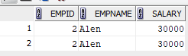

UPDATE emp_details SET salary = 10000WHERE empid = 1;
SELECT * FROM updated;

